**Prajapati Pavan**

**JQuery Basic, Effects & Advanced**

1. **What is JQuery?**

* JQuery is an inbuilt library of the JavaScript.
* JQuery is use to make easier to use JavaScript on website.
* JQuery simplified the complicated things of JavaScript.
* The basic syntax of JQuery is $(selector).action ().

1. **How to Apply CSS Using JQuery, How to Add Class and Remove Class in JQuery, JQuery Animation?**

**How to Apply CSS Using JQuery:**

* To apply CSS using JQuery “css()” is used.

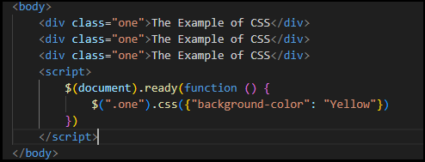

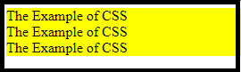

**How to Add Class and Remove Class in JQuery:**

* **addClass ():** method is use to add one or more classes to the elements.

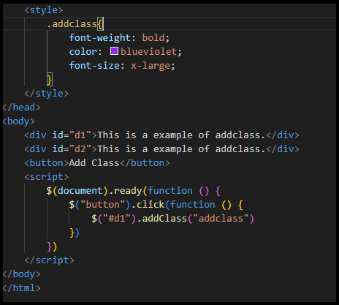

**Output:**

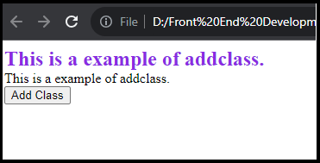

* **removeClass ()**: method is use to remove one or more classes to the elements.

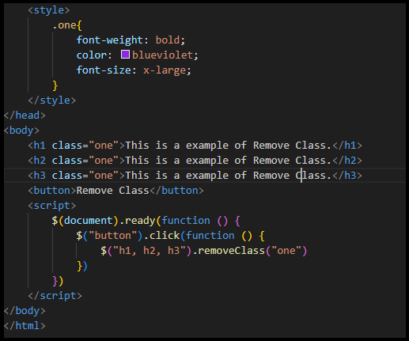

**Output:**

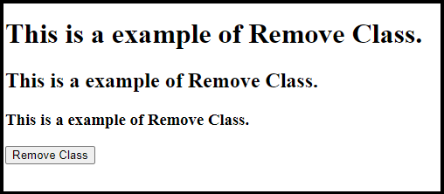

**JQuery Animation:**

* The **animate ()** method is use to create animations in JQuery.

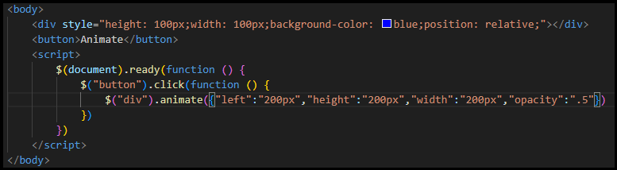

**Output:**

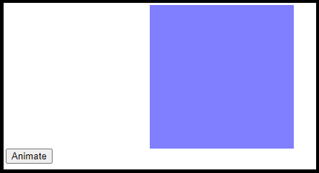

1. **How to create slider with animation?**

* We can create slider with following slide methods:
* **slideDown ():** This method is use to slide down an element.

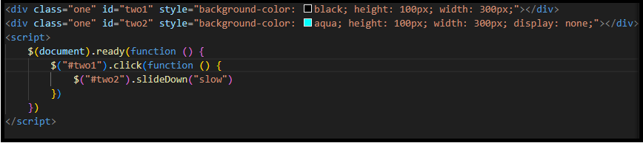

* **slideUp ()** : This method is use to slide up an element.

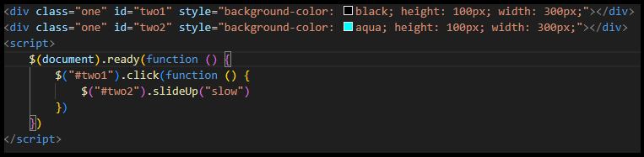

* **slideToggle():** This method to slide both up and down an element

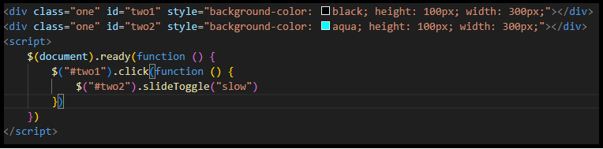

1. **Event bubbling tickling example**:

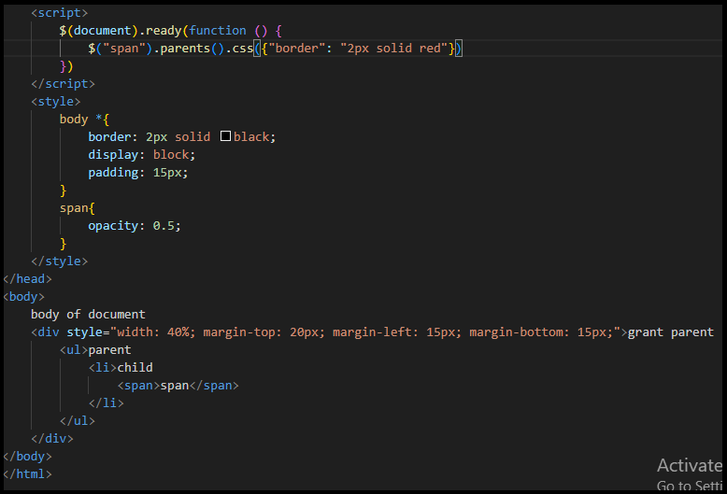

**Output:**

